Name : Prashant Ranjan Roll No : 24MC3035

Check if there is a simple path from s to d in a graph (adjacency matrix)

#include <iostream>
#include <vector>
using namespace std;

bool dfs(int u, int d, const vector<vector<int>>& adj, vector<int>& visited) {
if (u == d) return true;
visited[u] = 1;
int n = adj.size();
for (int v = 0; v < n; ++v) {
if (adj[u][v] == 1 && !visited[v]) {
if (dfs(v, d, adj, visited)) return true;
}
}
return false;
}

int main() {
vector<vector<int>> adj = {
{0,1,0,0,0},
{0,0,1,0,0},
{0,0,0,1,0},
{0,0,0,0,1},
{0,0,0,0,0}
};
int s = 0;
int d = 4;
vector<int> visited(adj.size(), 0);

if (dfs(s, d, adj, visited))
cout << "Simple path exists\n";
else
cout << "No simple path\n";

return 0;
}

Output:
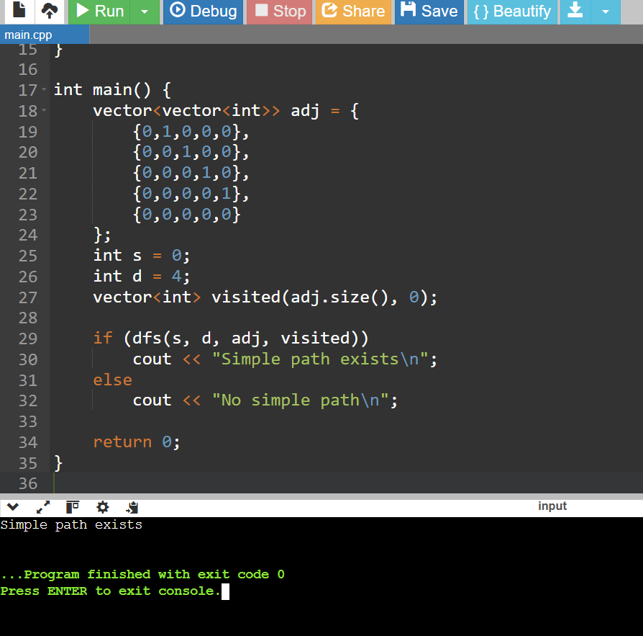

- Check if array has repeated elements (O(1) extra space idea)

#include <iostream>
#include <algorithm>
using namespace std;

int main() {
long long A[] = {5, 2, 1, 7, 2, 9};
int n = sizeof(A) / sizeof(A[0]);

sort(A, A + n);

bool hasRepeat = false;
for (int i = 1; i < n; ++i) {
if (A[i] == A[i - 1]) {
hasRepeat = true;
break;
}
}

if (hasRepeat)
cout << "Repeated elements are present\n";
else
cout << "No repeated elements\n";

return 0;
}

Output:
